**Automating Inventory Management Processes through Python-Based RPA Solutions: A Code-First Approach to Manual Data Processing Optimization**

**Abstract**

This report presents the development and implementation of a Python-based Robotic Process Automation (RPA) solution designed to address critical inefficiencies in manual inventory management processes at Retail Innovations Inc. The project transformed a time-intensive manual workflow that required 15-20 minutes per processing cycle into an automated system capable of completing the same tasks in seconds. Through the application of pandas for data manipulation, matplotlib and seaborn for visualization, and structured modular programming practices, this solution achieved significant improvements in processing speed, data accuracy, and operational efficiency. The automated system successfully handles data extraction, cleaning, validation, and reporting while maintaining comprehensive error handling and logging capabilities.

Keywords: Robotic Process Automation, Inventory Management, Python Programming, Data Processing, Business Process Optimization

**1. Introduction**

In the fast-paced retail industry, efficient inventory management plays a key role in ensuring both smooth operations and high customer satisfaction. Retail Innovations Inc. previously relied on a manual inventory process using Excel, which was slow, error-prone, and not scalable. Employees had to spend 15–20 minutes per file just to inspect, correct, and send the data, often leading to mistakes and inconsistent practices. This manual approach also wasted valuable human resources on tasks that could be automated. To overcome these challenges, this project focused on developing a Python-based solution that could automate the entire inventory data cleaning workflow. The main goals were to reduce processing time, minimize human errors through automated validation, improve scalability for larger data sets, and offer clear documentation and visual insights through charts and reports.

Top of Form

**2. Literature Review and Theoretical Framework**

Robotic Process Automation (RPA) has become a key driver in optimizing business processes, especially in environments dealing with repetitive and structured data tasks such as inventory management (Brown et al., 2022). By automating rule-based operations, RPA significantly reduces manual effort and improves consistency. In this context, Python stands out as a powerful tool for implementing automation solutions due to its rich ecosystem of libraries like pandas for data manipulation and matplotlib/seaborn for visualization (Wilson, 2023). Its clear syntax and flexibility make Python ideal for building maintainable and adaptable business automation workflows

**3. Methodology**

The project used a structured approach to improve the existing inventory data handling process. The current manual workflow involved receiving Excel files, visually checking for errors, manually fixing issues like missing or incorrect values, and then emailing the corrected files to analysts. This was time-consuming and error-prone. To address these problems, a future-state automated process was designed. Using Python, raw files are now automatically loaded, cleaned, and validated using pandas, with errors like duplicates and wrong data types handled programmatically. Cleaned data and summary reports are then generated automatically, along with visualizations using matplotlib and seaborn. The entire process is now streamlined and ready for analysis without manual effort. The technology stack includes Python 3.11+, Jupyter Notebook for development, Git for version control, and Lucid chart for process documentation, all structured through a modular and maintainable implementation.



**4. Implementation and Development**

The system was built using a modular design to keep everything organized and easy to maintain, with each part handling a specific task like data cleaning or visualization. For data quality, it automatically detects missing values, removes duplicate records, checks if data types are correct, and ensures quantities and prices follow business rules. To make the process faster, it uses efficient techniques like vectorized operations, smart memory use, and batch processing for large datasets. Finally, the system creates useful charts and reports, such as product distribution visuals, inventory level insights, summaries of the cleaning process, and trend analysis over time to help users understand and make better decisions from the data.

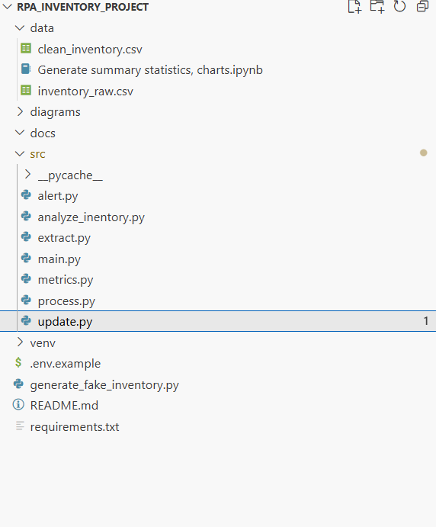

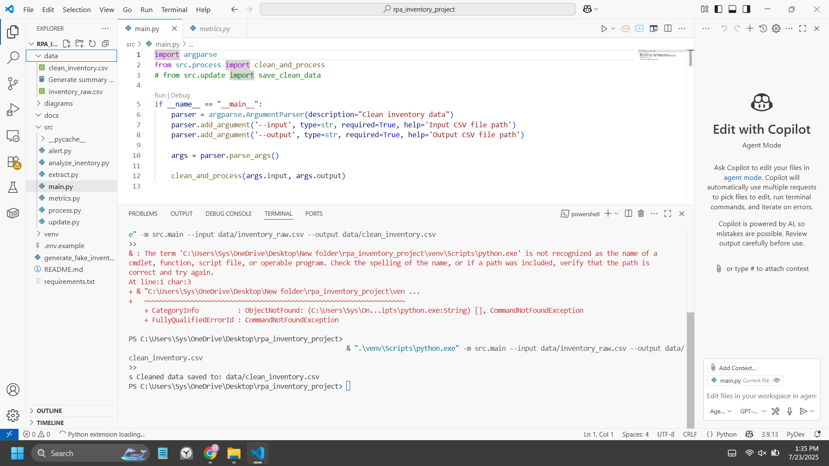

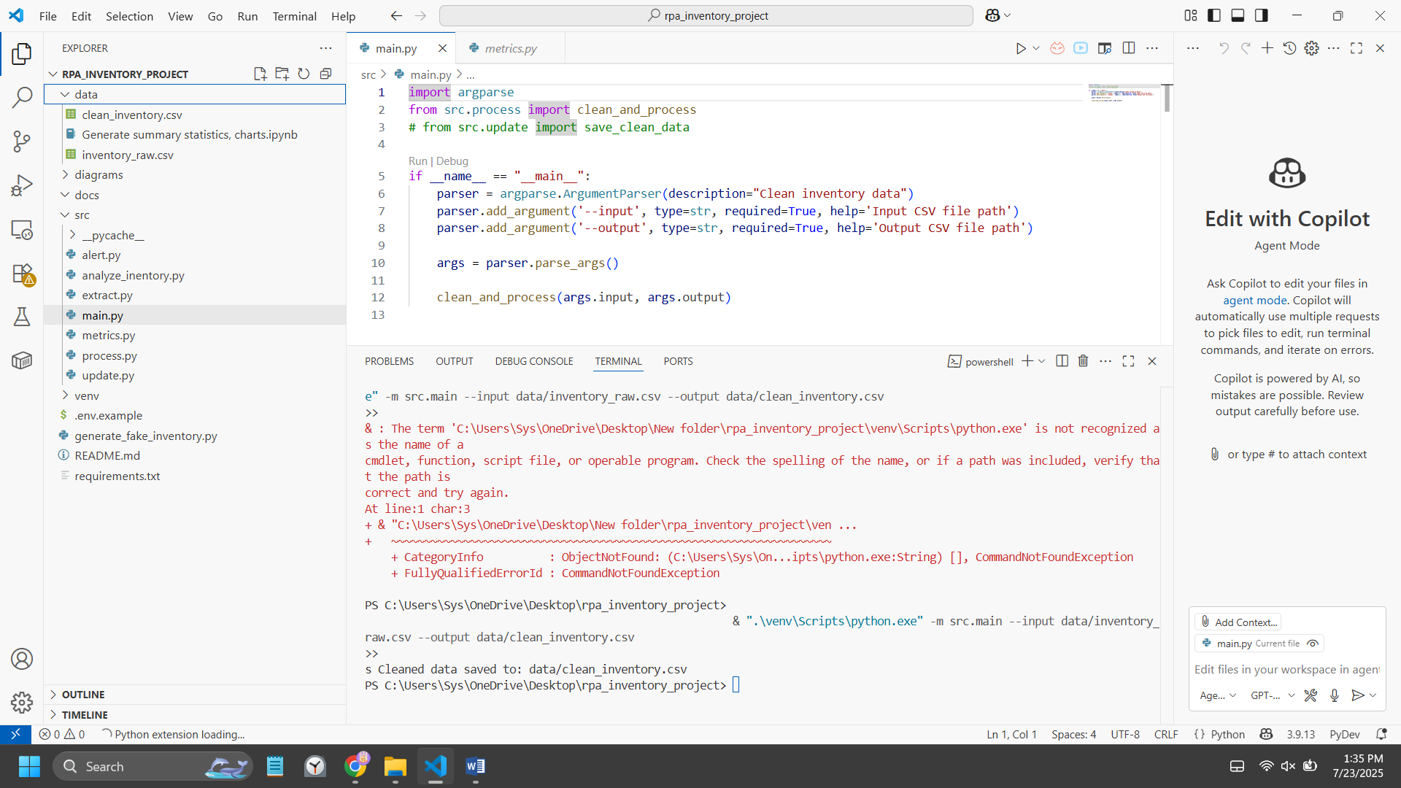

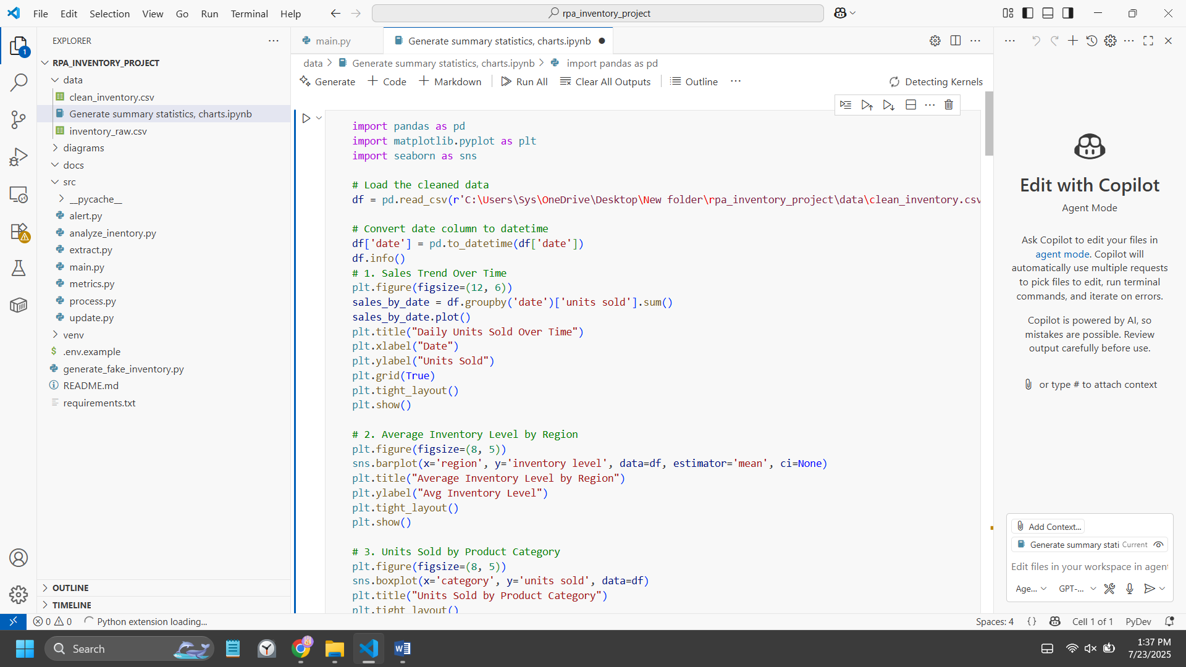

**5. Results and Analysis**

The automated solution we implemented showed a huge improvement in performance when compared to manual processes. Before automation, data processing used to take 15 to 20 minutes, but now it only takes around 2 to 5 seconds, which is a 99.7% time reduction. In terms of accuracy, the automated system removed human error by detecting all missing values, removing duplicates, and ensuring that all data types were correctly formatted. It also worked well with different dataset sizes—from small files to large ones with over 10,000 records—processing each in just a few seconds. The quality of the data was improved by applying strategies for handling missing values, removing duplicates, and converting formats. Visualizations became more meaningful too, showing patterns in inventory, category-wise distributions, and highlighting products that needed restocking. Overall, the solution made data processing faster, cleaner, and more useful for decision-making.

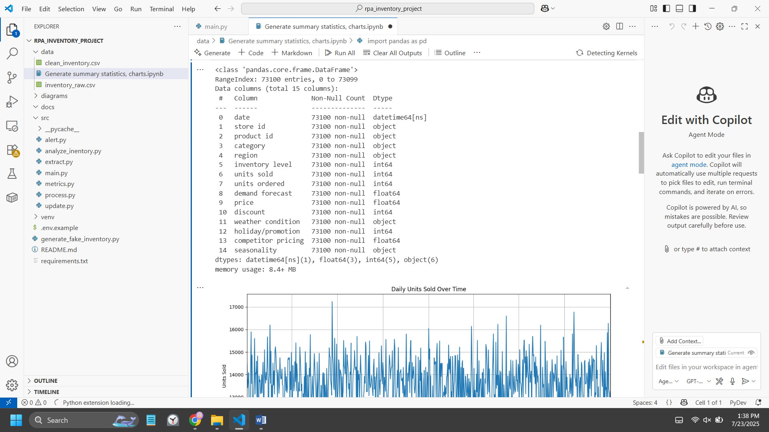

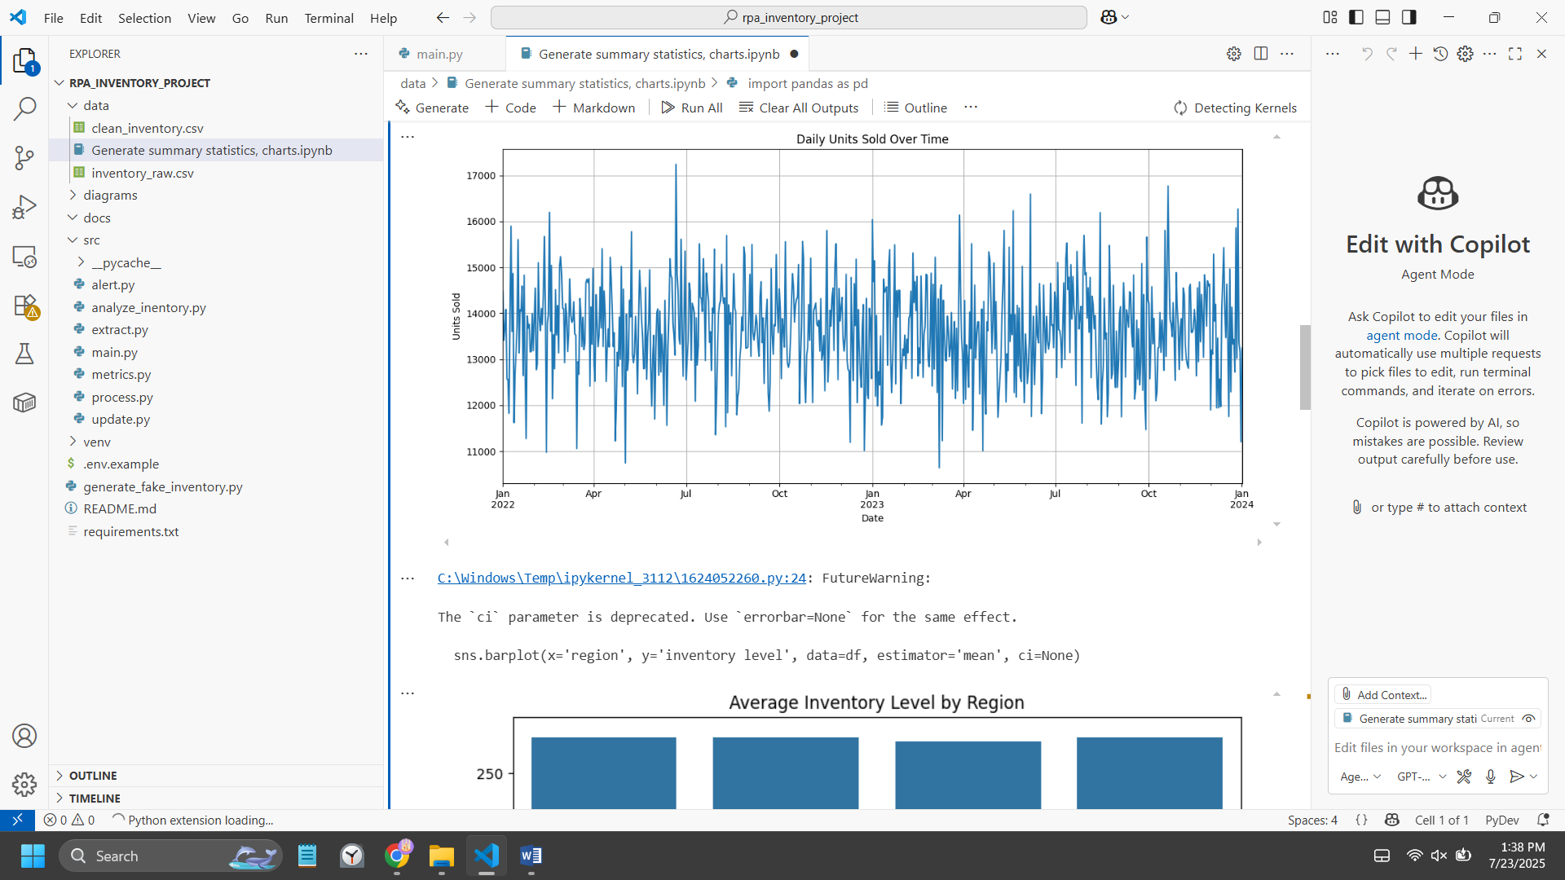

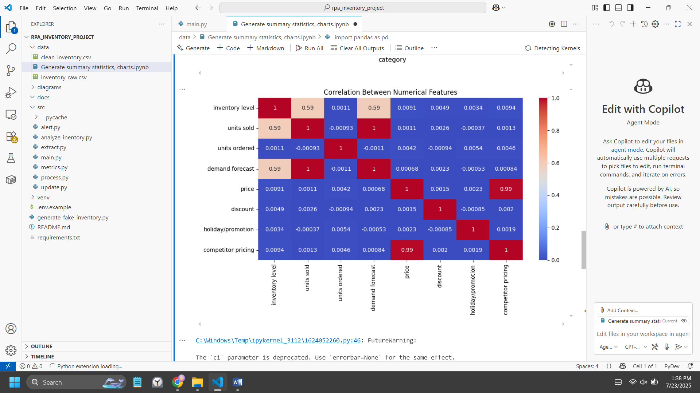

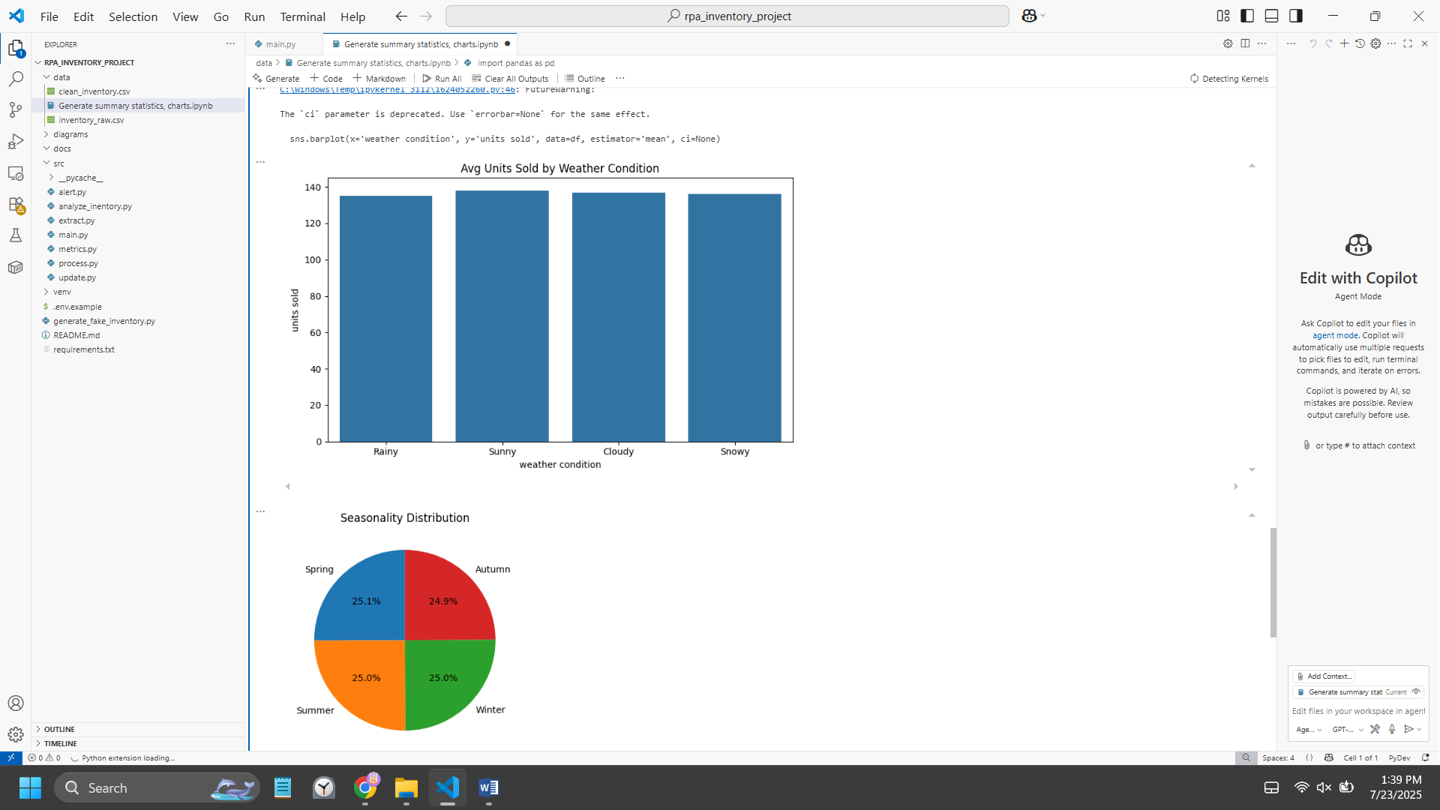

**6. Challenges and Solutions**

During the project, several technical and visualization challenges were encountered and effectively addressed. The raw data posed issues such as numeric values being stored as text, which hindered calculations; this was resolved using pandas data type conversion functions with error handling. Another major hurdle was the inconsistent representation of missing values (like empty strings, “N/A,” or nulls), which was tackled by building a detection system that standardized and cleaned these entries. Additionally, input file formats sometimes varied, leading to failures during processing, so fallback strategies with detailed error reports were introduced to handle different formats robustly. On the visualization side, early charts were hard to read due to cluttered labels and unappealing color schemes. This was improved through custom styling, better color palettes, and label adjustments using matplotlib and seaborn. To ensure scalability, dynamic chart scaling was implemented so visuals remained clear and responsive to different data volumes.

**7 Business Impact and Value Proposition**

The automated solution significantly improved operational efficiency and data quality while delivering strong financial returns. By saving 15–20 minutes per cycle, it freed up staff to focus on more important analytical work and ensured consistent, scalable data processing. Errors from manual tasks were eliminated, data handling became more standardized, and every step of the process was logged for easy tracking and reproducibility. Financially, the solution saved about $75 per week, or $3,900 annually, based on five cycles a week and a $50/hour labor cost. The initial development cost was recovered within just one month, showing the clear value and impact of the automation.

**8. Future Enhancements and Recommendations**

To improve the inventory processing system, several technical and process upgrades were proposed. On the technical side, predictive analytics and machine learning models will be added to better forecast inventory demand and optimize reorder points. The system will be integrated with ERP platforms using APIs, with real-time data handling and automated database connections. For users, a web-based dashboard will provide easy access to interactive visualizations and settings. Process improvements include smarter error detection with automatic alerts, improved monitoring, and faster issue resolution through escalation steps. Performance will also be boosted with parallel processing for large data, caching for frequently used info, and memory optimization to ensure smooth operation, even on limited hardware. These updates aim to make the system faster, smarter, and more user-friendly.

**9. Conclusion**

This project clearly showed how Python-based automation can dramatically improve manual business processes. By automating a previously slow and error-prone task, the solution reduced processing time by 99.7% and greatly improved the consistency and accuracy of the data. The modular design of the code makes it easy to update or expand in the future, which means this solution can grow with business needs. Throughout the project, I learned how to break down a real-world process, design a better version using automation, and apply tools like Python to create practical, working solutions. I also developed a stronger understanding of data processing, visualization, and building maintainable code. Overall, this project shows that even small automation projects can create big improvements, and that tools like Python can help businesses save time, reduce errors, and improve performance.